**THE CASE OF CAIN VELASQUEZ**

WHAT STARTED EVERYTHING

Cain Velasquez’s 4-year-old son attended a well-known daycare run by Harry Eugene Goularte's mother, Patty Goularte, in San Martin, CA. Harry Goularte, a 43-year-old male, lived at the same house that hosted the daycare.

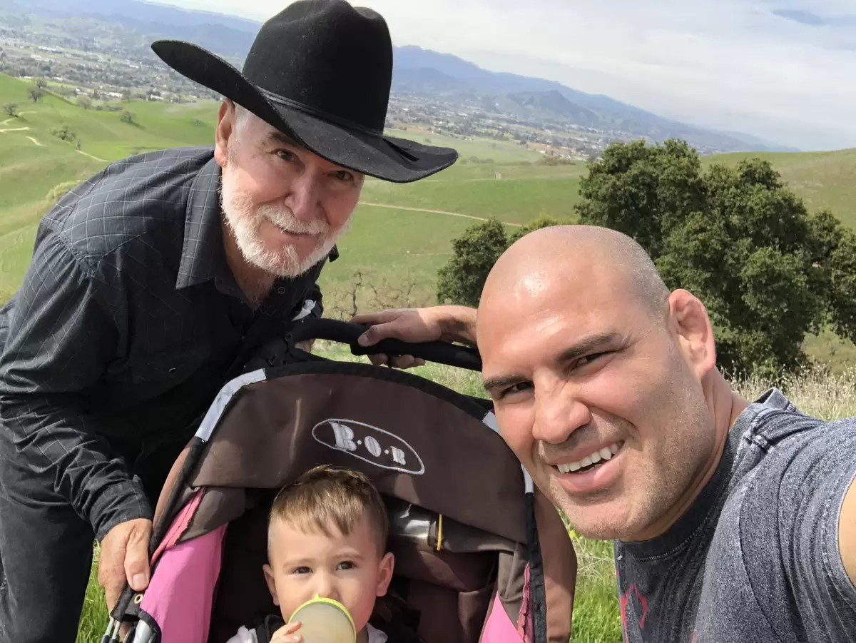Cain Velasquez, his father Efrain Velasquez and his son, Cain Velasquez, Jr.

On February 23, 2022, Sheriff’s responded to the daycare in San Marin on reports of prior sexual assault involving a child. Goularte was accused of inappropriately touching a juvenile victim on **multiple occasions (over 100 times)**. A Complaint filed by the Velasquez family accused Goularte of removing the child’s clothing, touching the child’s privates, and exposing himself to the child “numerous times” from 2021-2022.

After conducting interviews with the 4-year-old victim and associated parties, investigators determined a sexual assault occurred in the daycare’s bathroom. “The child victim said the suspect told him not to tell anyone.”

Goularte told police conflicting information about how he interacted with children at Patty’s Daycare, the detective said. First he told police that he had “no involvement with the children. The suspect then changed his statement and said he sometimes wrestled and played with some of the children.

Detectives arrested Harry Eugene Goularte Jr. and charged Goularte with one felony count of a lewd and lascivious act with a child under the age of 14. Bail was set at $50,000.

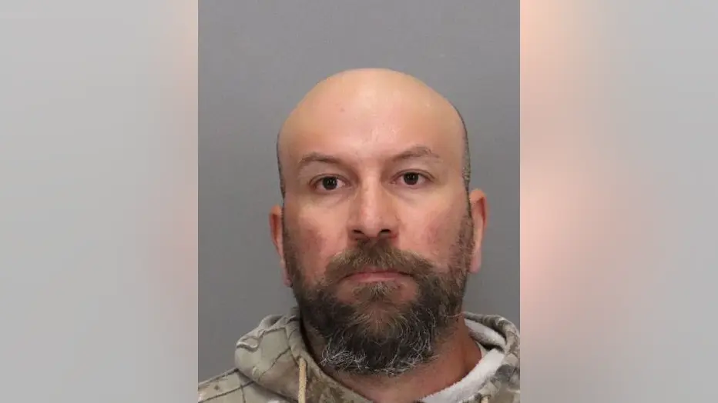

-Harry Goularte, Jr.

Detectives determined there were more than 20 children who attended this daycare establishment. Detectives believe there are additional juvenile daycare participants who previously attended this daycare who could be potential victims.

Goularte was arraigned and a judge granted him supervised release, over objections from the Santa Clara County District Attorney’s Office.

WHAT DID CAIN DO

Three days later, on February 28, 2022, Cain Velasquez drove his Black Ford F250 from his Gilroy home to the home of Harry Goularte. Goularte and his parents were leaving to get Goularte fitted with an electronic monitoring bracelet.

Shortly after getting into his parents’ pickup truck in Morgan Hill, authorities say Velasquez first shot at Goularte, triggering a high-speed chase from Morgan Hill into South San Jose. Velasquez pursued Goularte who was in a Silverado, with his mother in the back seat and his stepfather driving away. Velasquez started shooting at the truck which was at the intersection of Butterfield Boulevard and Cochrane Road, then rammed his truck into the Goularte’s Chevy twice. Meanwhile, Patty Goularte called 911. Velasquez fired two more shots, hitting Paul Bender in the right arm and torso.

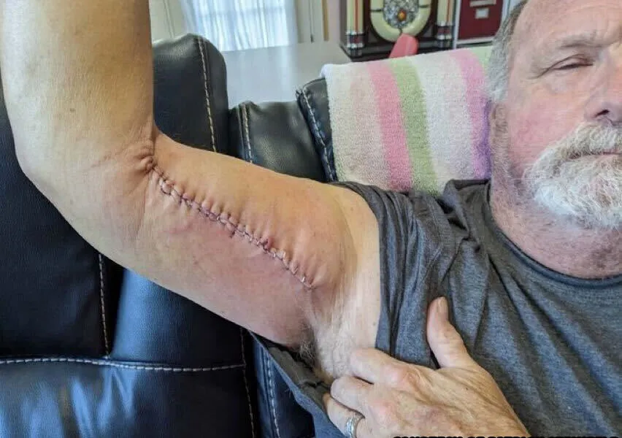

-Paul Bender and injury

Patty Goularte said she was crouched down in the vehicle hiding when she heard the bullets piercing metal of their vehicle.

Velasquez allegedly fired seven shots from his .40 cal semi-automatic in total. Shell casings were all over the place – in his truck, lodged in Goularte’s truck, and in the intersection. Velasquez has another magazine loaded and ready to go when he was arrested for attempted murder of Paul Bender.

Cain Velasquez was incarcerated for nearly nine months and was denied bail three times before being granted bail, which cost $1 million.

CHARGES

CAIN VELASQUEZ

-one count of attempted murder, premeditated – mandatory life in prison.

-one count of shooting at a motor vehicle or aircraft – 3, 5, or 7 years in prison.

-three counts of assault with a firearm – 6 months to 4 years each count.

-three counts of assault with a deadly weapon – 1 month to 4 years each count.

-one count of willfully discharging a firearm from a vehicle – 6 months to 7 years.

-one count of carrying a loaded firearm with intent to commit a felony – up to 1 year.

Total Possible Prison Time: life + up to 39 years.

HARRY GOULARTE

- Lewd and lascivious acts with a minor - eight years in prison and/or a $10,000 fine.

PLEA

Velasquez will plead No Contest to attempted murder and multiple firearms-related crimes.

In exchange, premeditation allegations have been dropped by prosecutors, meaning a mandatory life sentence is no longer in play, however, that doesn’t mean the judge can’t sentence Velasquez to life in prison.

Velasquez will be convicted of the charges against him as a result of the plea, with a sentencing hearing on October 18, 2024.

Possible Sentence – Probation to Life in Prison.

The judge has wide discretion on Velasquez’s sentence, and in the coming months the county probation department will produce a sentencing recommendation report weighing the severity of his crime along with potential mitigating factors, including his lack of criminal history and the sexual abuse case in which his son is a reported victim.

Meanwhile, Velasquez remains out of custody with his existing bail, home detention and supervised monitoring conditions in place.

DID GOULARTE’S MOTHER AND STEPFATHER KNOW?

The complaint alleges Patricia Goularte, Paul Bender, and Patty’s Childcare staff “allowed this behavior and conduct to occur and continue to occur and failed to adequately monitor and supervise [the victim] and Harry.”

“Despite the warnings, observations, and signs of inappropriate behavior and conduct, Harry, at all times, remained permitted to reside on the property of Patty’s Childcare,” the document states.

MMA Junkie confirmed through social service documents that the daycare had 10 violations since 2018, though none were sexual in nature. In 2018, the daycare was written up twice for being “out of ratio,” meaning an inadequate number of supervisors for the amount of children present.

The first violation narrative stated “LPA observed licensee and two assistants working in backyard preparing for an invent. All children were in the home without supervision.”

Multiple inspection reports referenced Harry Goularte and Paul Bender by name and cited that both had passed necessary criminal background checks and received child abuse index clearances or exemptions – the most recent in January 2022. Patricia Goularte is listed as having a daycare license since 1988.

WHAT WOULD I HAVE DONE?

I would not have shot Goularte.

As a former UFC Champion with victories over Junior Dos Santos, Brock Lesnar and Antonio ‘Bigfoot’ Silva, Cain Velasquez has a unique set of tools he could have utilized to mete out justice.



- Cain Velasquez vs Antonio Silva

I would have followed him, beat the living shit out of him, broken every bone in his hands, then broken both wrists, multiple ribs, multiple facial bones, then crushed his testicles – literally crush with foot stomps.

I would get arrested and probably get charged with aggravated assault. That sentence carries a 4-year prison term and a $10,000 fine. I would gladly do that time.

But hindsight is 20/20 and it’s easy for me to sit here behind my keyboard contemplating exactly what I would do. Blood runs deep, but parenting with emotions has consequences.